1. Provide a screenshot of your Docker desktop showing the Cassandra *container* running in port 9042.



1. Provide screenshots to show that the write.py file was created in VS Code and that it contains the following required elements:
   1. A keyspace called books.

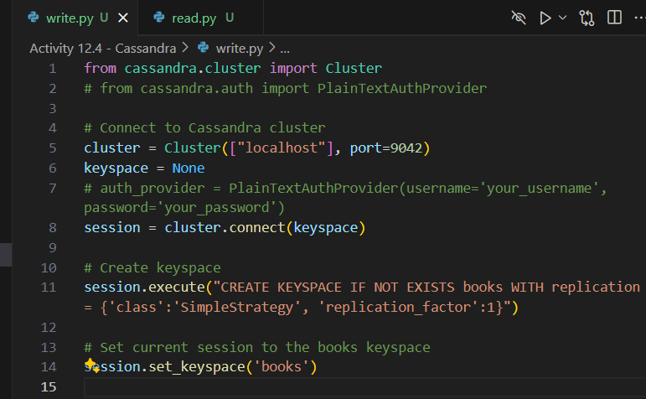

* 1. A table called book that contains the columns and rows defined in the activity instructions.

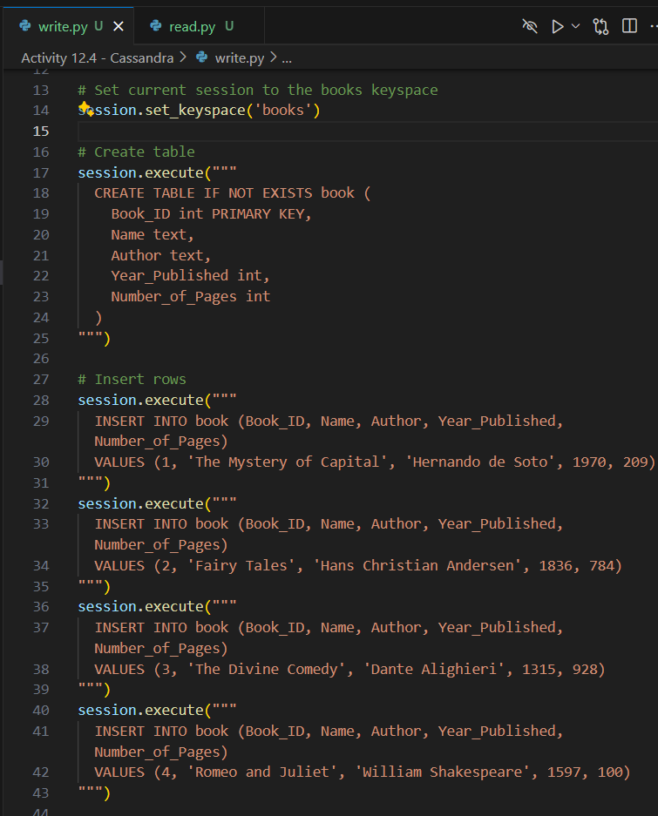

1. Provide screenshots to show that the read.py file was created in VS Code and that it contains the four books within the books keyspace.

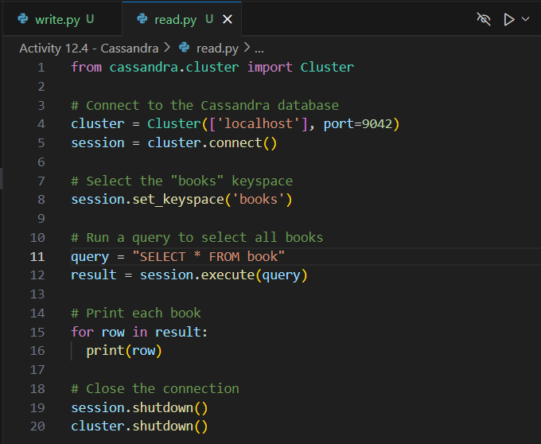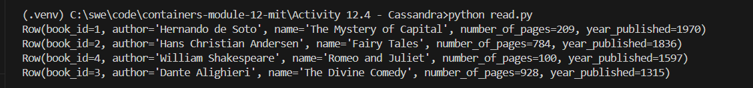

1. Provide a screenshot of the cqlsh window to show that insert *statement* has been run to add the fifth book to the books keyspace.

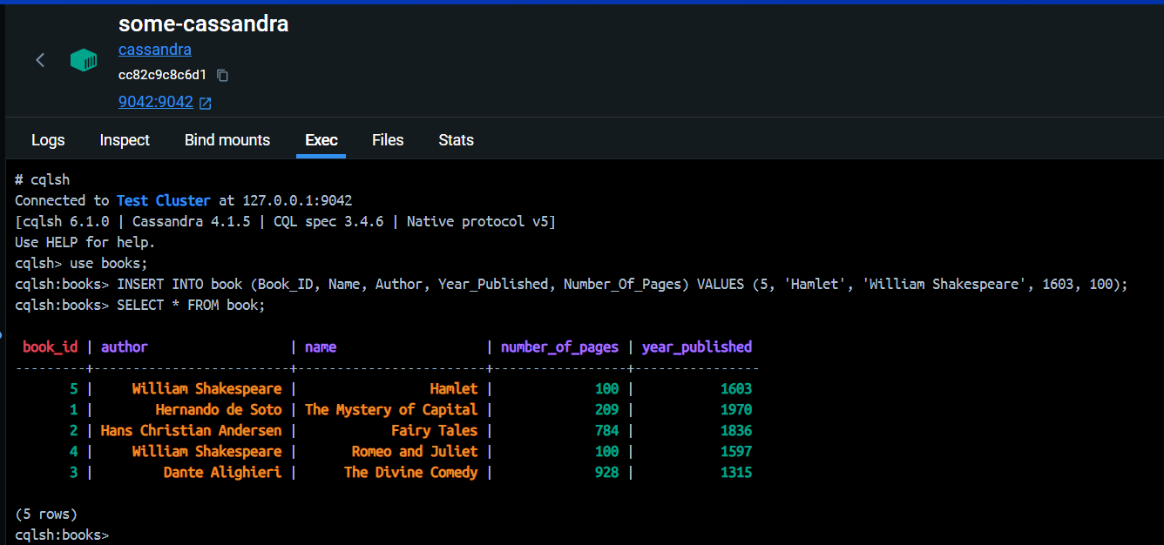

1. Provide a screenshot of the cqlsh window showing the results of the SELECT *statement* with all books in the books keyspace selected.

